2200032991  
  
WEEK-5 ADDITIONAL HANDS-ON

Create Eureka Discovery Server and register microservices

Here from the question given we need to generate total 5 zip files from the below ink

Like this total 4 files

Names are different but the dependencies should be **EUREKA SERVER**

**Make sure that it is in maven to get your pom.xml file**

Change your artificate names

1. Account
2. Api-gateway
3. Eureka-discovery-server
4. Greet-service
5. Loan

Download and extract them

Keep them in a file as shown

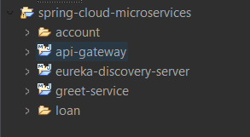

Now go to the vs code and open your files   
**open all and run them in the terminal With respect to their paths**

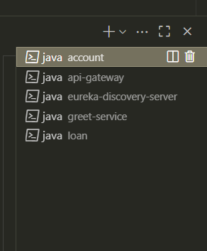

Change the application.properties and see the required info is there

Add the controller file

Eureka-discovery-server

<http://localhost:8761>

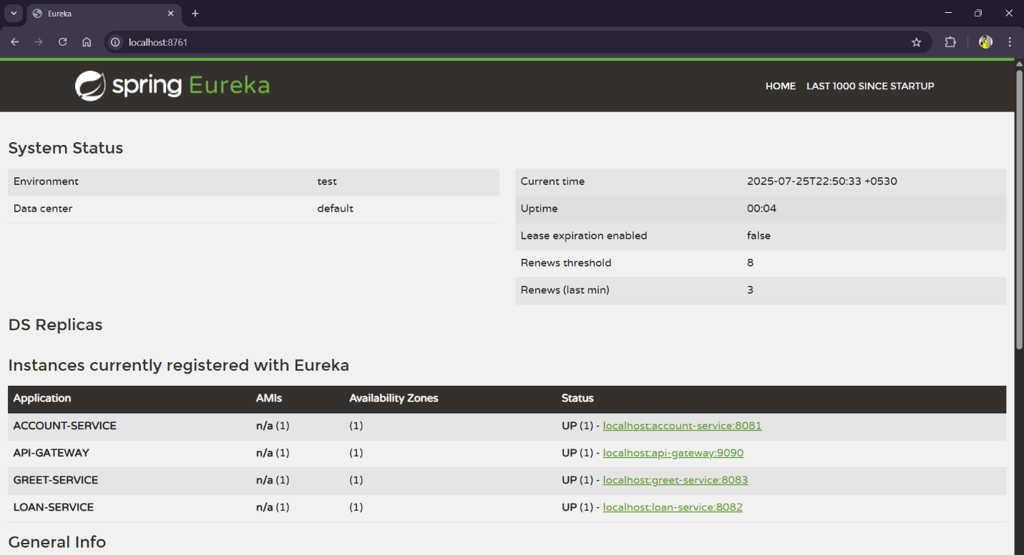

LOAN <http://localhost:8761>

Greet-service

<http://localhost:8083/greet>

API GATE WAY

<http://localhost:9090/greet-service/greet>

